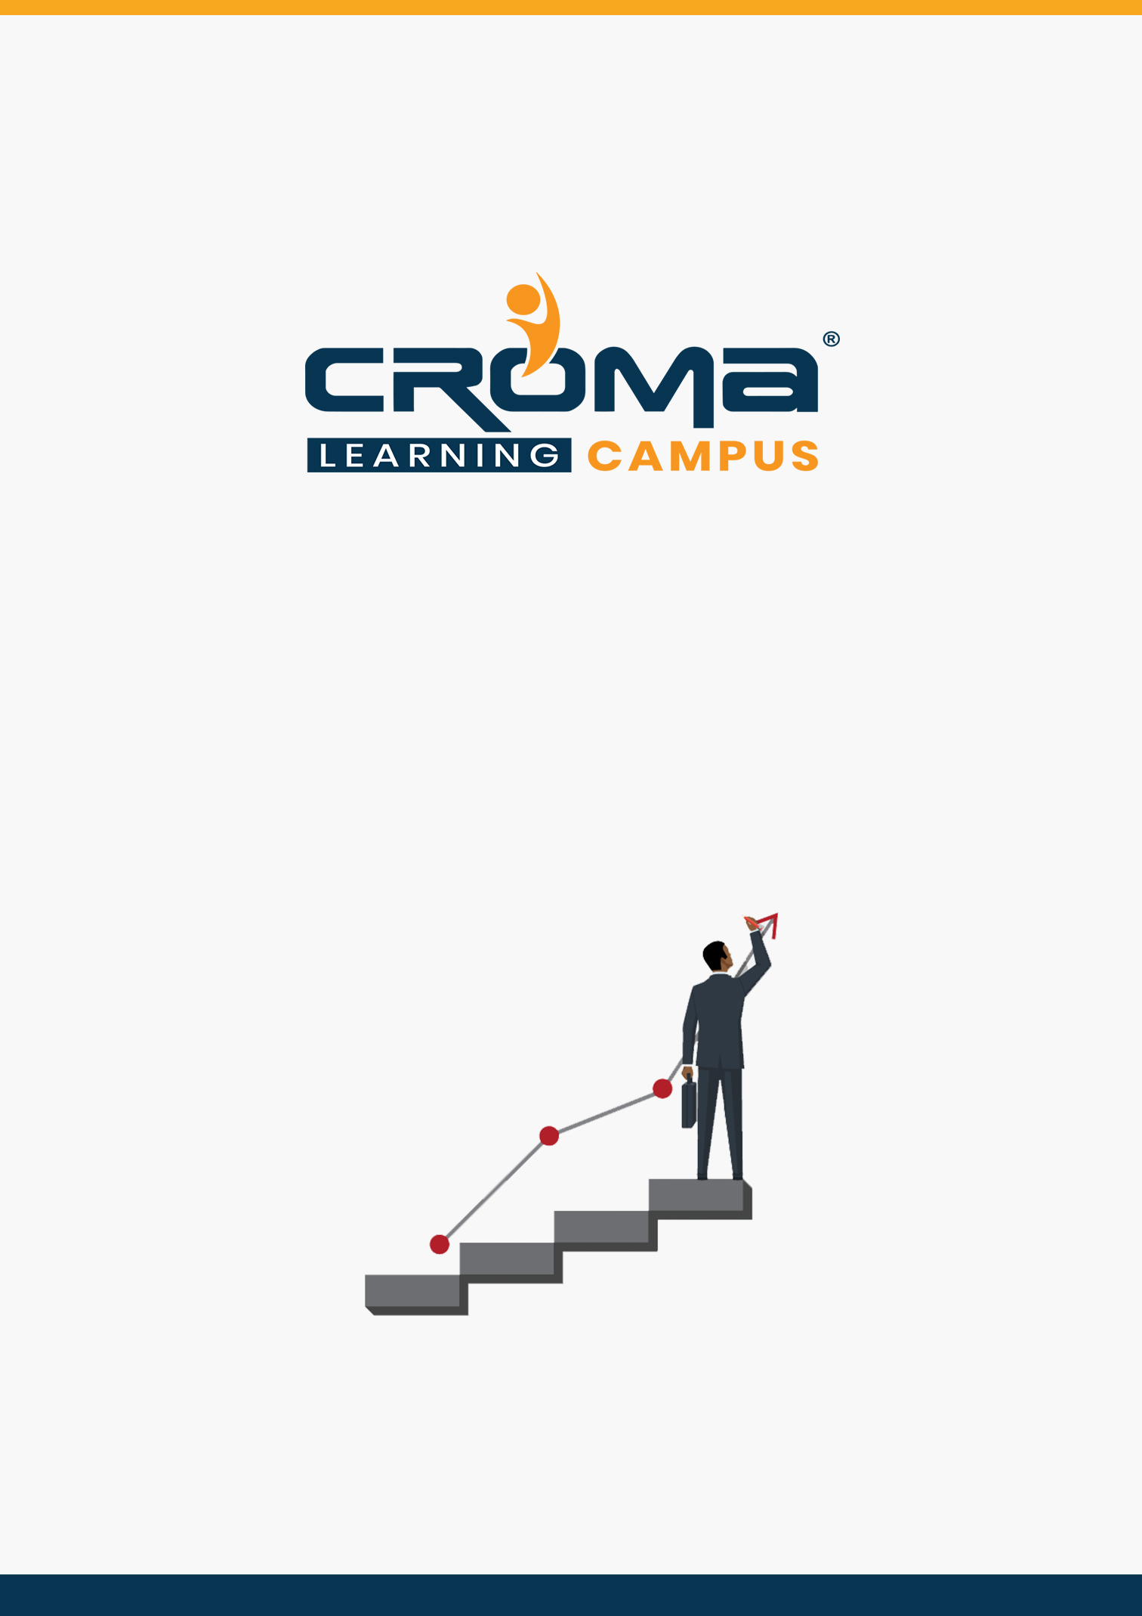

**AZ-300 Microsoft Azure Architect Technologies Training Curriculum**

**STRUCTURE**

**www.cromacampus.com | helpdesk@cromacampus.com | +91-120-4155255**

**AZ-300 Microsoft Azure Architect Technologies Training Curriculum**

*“Learn translating complex business requirements into reliable and scalable cloud solutions with our detailed Curriculum for AZ 300 Certification Training”*

**Course Objectives:**

* Prepare yourself for the certification exam and clear your certification exam in the first attempt
* Add an attractive credential in your resume that is really appreciated by Companies.
* Improve your overall Cloud management skills, azure development skills, solution designing, implementation skills, and explore more job prospects with better salary packages.
* Boost your social media profiles especially LinkedIn by adding this certification and become one of the top persons to be chosen by industries.

**AZ 300 Certification Training Description:**

The job role and responsibilities for an Azure Solution Architect include advising stakeholders and translating business requirements into secure, scalable, and reliable cloud solutions. Also, an Azure Solution Architect partners with cloud administrators, cloud DBAs, and clients to implement solutions.

After joining our Training program at Croma Campus, you will gain subject matter expertise in designing and implementing solutions that run on Microsoft Azure, including aspects like compute, network, storage, and security.

***Here are some strong reasons why should you consider this certification course.***

* Validate your technical skills like storage, networking, compute, security, and other Cloud operations on Microsoft Azure.
* Validate your solution designing and architect skills by successful implementation of cloud solutions at the workplace.
* Top-paying info-tech certification in the world.
* It provides you with global recognition for your knowledge, skills, and experience.
* The organization looks for those who know Oracle Cloud, AWS, Azure, etc.

**Prerequisites for the Certification Exam:**

A candidate for this exam should have advanced experience and knowledge across various aspects of IT operations, including networking, virtualization, identity, security, business continuity, disaster recovery, data management, budgeting, and governance–this role should manage how decisions in each area affect an overall solution.

In addition, this role should be proficient in at least one of these Azure knowledge domains: AZ 103 administration, AZ 203 development, or DevOps.

**Necessary Details about Certification You must Know**

* Certification Name – AZ-300 Microsoft Azure Architect Technologies
* Exam Duration: 150 minutes
* Number of Questions: 40-60
* Passing score: 700 (Out of 1000)
* Exam Cost: USD 165.00
* Validity: 2 years

**Certification Exam Structure:**

* Deploy and configure infrastructure (40-45%)
* Implement workloads and security (25-30%)
* Create and deploy apps (5-10%)
* Implement authentication and secure data (5-10%)
* Develop for the cloud and for Azure storage (15-20%)

**Course Content:**

**Module 1: Introduction**

* Course Overview
* Introduction to Cloud computing
* Introduction to Azure
* Self-hosting to cloud hosting
* Azure Services
* Azure Regions

**Module 2: Virtual Machines**

* What is a Virtual Machine?
* The Azure Portal
* Create a Virtual Machine in Azure
* Test a Virtual Machine in Azure
* Create a Virtual Machine
* Configure a VM for Availability
* Monitor a VM
* Setting up Virtual Machine Scale Sets (VMSS)
* Working with ARM Templates
* Deploy a Linux VM using ARM Templates
* Encrypt a VM

**Module 3: Analyse Resource Utilization and Consumption**

* Configure Diagnostic Settings on Resources
* Create Baseline for Resources
* Create and Test Alerts
* Create and Test Metrics
* Create Action Groups
* Monitor and Manage Azure Costs
* View Alerts in Log Analytics
* analyze alerts across subscription
* analyze metrics across subscription
* create action groups
* monitor for unused resources
* monitor Spend
* Report on spend
* utilize Log Search query functions
* view Alerts in Azure Monitor logs
* visualize diagnostics data using Azure Monitor Workbooks

**Module 4: Create and configure storage accounts**

* Configure network access to the storage account
* Create and configure storage account
* Generate Shared access signature
* Implement Azure AD authentication for storage
* Install and use Azure Storage Explorer
* Manage access keys
* Monitor Activity log by using Azure Monitor logs
* Implement Azure storage replication
* Implement Azure storage account failover

**Module 5: Deploy and Configure Infrastructure**

* Create connectivity between virtual networks
  + create and configure Vnet peering
  + create and configure Vnet to Vnet connections
  + verify virtual network connectivity
  + create virtual network gateway
* Implement and manage virtual networking
  + configure private IP addressing
  + configure public IP addresses
  + create and configure network routes
  + create and configure network interface
  + create and configure subnets
  + create and configure virtual network
  + create and configure Network Security Groups and Application Security Groups
* Manage Azure Active Directory
  + add custom domains
  + configure Azure AD Identity Protection
  + configure Azure AD Join
  + configure self-service password reset
  + implement conditional access policies
  + manage multiple directories
  + perform an access review
* Implement and manage hybrid identities
  + install and configure Azure AD Connect
  + configure federation
  + configure single sign-on
  + manage and troubleshoot Azure AD Connect
  + troubleshoot password sync and writeback
* Implement solutions that use virtual machines (VM)
  + provision VMs
  + create Azure Resource Manager templates
  + configure Azure Disk Encryption for VMs
  + implement Azure Backup for VMs

**Module 6: Implement Workloads and Security**

* Migrate servers to Azure
* Configure serverless computing
  + create and manage objects
  + manage a Logic App Resource
  + manage Azure Function app settings
  + manage Event Grid
  + manage Service Bus
* Implement application load balancing
  + configure application gateway
  + configure Azure Front Door service
  + configure Azure Traffic Manager
* Integrate on premises network with Azure virtual network
  + create and configure Azure VPN Gateway
  + create and configure site to site VPN
  + configure ExpressRoute
  + configure Virtual WAN
  + verify on premises connectivity
  + troubleshoot on premises connectivity with Azure
* Implement multi factor authentication
  + configure user accounts for MFA
  + configure fraud alerts
  + configure bypass options
  + configure Trusted IPs
  + configure verification methods
* Manage role-based access control
  + create a custom role
  + configure access to Azure resources by assigning roles
  + configure management access to Azure
  + troubleshoot RBAC
  + implement Azure Policies
  + assign RBAC Roles

**Module 7: Create & Deploy Apps**

* Create web apps by using PaaS
  + create an Azure app service Web App
  + create documentation for the API
  + create an App Service Web App for Containers
  + create an App Service background task by using Web Jobs
  + enable diagnostics logging
* Design and develop apps that run-in containers
  + configure diagnostic settings on resources
  + create a container image by using a Docker file
  + create an Azure Kubernetes Service
  + publish an image to the Azure Container Registry
  + implement an application that runs on an Azure Container Instance
  + manage container settings by using code

**Module 8: Implement authentication and secure data**

* Implement authentication
  + implement authentication by using certificates, forms-based authentication, tokens, or Windows-integrated authentication
  + implement multi-factor authentication by using Azure AD
  + implement OAuth2 authentication
  + implement Managed Identities for Azure resources Service Principal authentication
* Implement secure data solutions
  + encrypt and decrypt data at rest and in transit
  + encrypt data with Always Encrypted
  + implement Azure Confidential Compute
  + implement SSL/TLS communications
  + create, read, update, and delete keys, secrets, and certificates by using the KeyVault API

**Module 9: Develop for the cloud and for Azure Storage**

* Configure a message-based integration architecture
  + configure an app or service to send emails
  + configure Event Grid
  + configure the Azure Relay service
  + create and configure a Notification Hub
  + create and configure an Event Hub
  + create and configure a Service Bus
* Develop for autoscaling
  + implement autoscaling rules and patterns (schedule, operational/system metrics)
  + implement code that addresses singleton application instances
  + implement code that addresses transient state
* Develop solutions that use Cosmos DB storage
  + create, read, update, and delete data by using appropriate APIs
  + implement partitioning schemes
  + set the appropriate consistency level for operations
* Develop solutions that use a relational database
  + provision and configure relational databases
  + configure elastic pools for Azure SQL Database
  + implement Azure SQL Database managed instances
  + create, read, update, and delete data tables by using code

**Module 10: Placement Guide**

* What is an Interview?
* Tips to clear an Interview
* Common Interview questions and answers
* AZ 300 Interview Questions and Answers
* Resume Building Guide
* Attempt for AZ 300 Global Certification Exam
* Start applying for Jobs